
c

Firmware Version: | 1.00.018
Boot Code Version: | 1.00.010
MIB Version: | 1.00.010
D-View Module Version: | 1.0.0.7
Published: | Nov. 08, 2011

These release notes include important information about D-Link switch firmware revisions. Please verify that these release notes are correct for your switch:
- If you are installing a new switch, please check the hardware version on the device label; make sure that your switch meets the system requirement of this firmware version. Please refer to Revision History and System Requirement for detailed firmware and hardware matrix.
- If the switch is powered on, you can check the hardware version by typing “show switch” command via Telnet or by checking the device information page on the web graphic user interface.
- If you plan to upgrade to the new firmware release, please refer to the Upgrade Instructions for the correct firmware upgrade procedure.
For more detailed information regarding our switch products, please refer to Related Documentation.
You can also download the switch firmware, D-View modules and technical documentation from http://tsd.dlink.com.tw.

Content:
Revision History and System Requirement: 2
Upgrade Instructions: 2
Upgrade using CLI (via Telnet) 2
Upgrade using Web-UI 3
New Features: 4
Changes in MIB & D-View Modules: 7
Changes in Command Line Interface: 10
Problem Fixed: 11
Known Issues: 12
Related Documentation: 13

Revision History and System Requirement:
Firmware Version | Date | Model | Hardware Version
Runtime: v1.00.018  Boot: 1.00.010 | 08-Nov.-11 | DGS-1500-28P | A1

Upgrade Instructions:
D-Link Smart Switches support firmware upgrade via TFTP server. You can download the firmware from D-Link web site http://tsd.dlink.com.tw, and copy the downloaded firmware to the TFTP server folder. Please make sure that the TFTP server is accessible from the switch via networks.

Upgrade using CLI (via Telnet)
1. Make sure the network connection between the switch and PC is active.
2. Use software that supports telnet, for example, HyperTerminal or Telnet command in Microsoft Windows, to connect to the switch. If you are using Telnet command, type the command followed by the switch IP address, eg. telnet 10.90.90.90.
3. The logon prompt will appear.

The switch will prompt the user to enter his/her username and password. It should be noted that upon the initial connection, both the default user name and password are admin.
To upgrade the switch firmware, execute the following command:

Command | Function
download{firmware_fromTFTP tftp://ip-address/filename | cfg_fromTFTP tftp://ip-address/filename} | Download firmware file from the TFTP server to the switch.
When completing firmware upgrade, the following messages will pop up.
Device will reboot after firmware upgraded successfully
Image upgraded successfully

4. Execute the following command to check the firmware version and switch’s information.
Command | Function
show switch | Display the information of current firmware and boot version.

Example:

- DGS-1500-28P:
Command: download firmware_fromTFTP tftp://10.90.90.91 DGS-1500-28P A1 1_00_018.hex
Device will reboot after firmware upgraded successfully
Image upgraded successfully

- DGS-1500-28P:
Command: show switch
DGS-1500-28P> show switch
System name :
System Contact :
System Location :
System up time : 0 days, 1 hrs, 58 min, 27 secs
System Time : 01/01/2011 02:33:34
System hardware version : A1
System firmware version : 1.00.018
System boot version : 1.00.010
System Protocol version : 2.001.004
System serial number : 1MB1733K0000A
MAC Address : 00-15-00-28-D0-0F

Upgrade using Web-UI
- Connect a workstation installed with java SE runtime environment to any switch port of the device.
- Open the web browser from the workstation and enter the IP address of the switch. The switch’s default IP address is 10.90.90.90.
- Enter administrator’s password when prompted. The password is admin by default.
- To update switch's firmware or configuration file, select Tools > Firmware Backup & Upgrade from the banner.

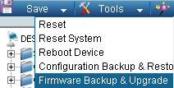v

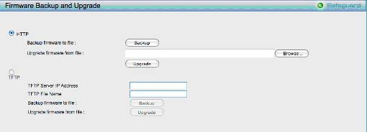
- Two methods can be selected : HTTP or TFTP

- Select HTTP to upgrade the firmware to or from your local drive of PC.
- Click Browse to browse your inventories for a saved firmware file
- Click Upgrade after selecting the firmware file you want to restore
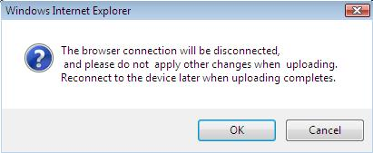
- Click OK to continue with firmware upgrade

- Click OK to continue with firmware upgrade
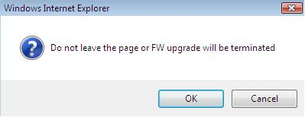

- Wait until the “Firmware Upgrade Successful” message pops up and login again after device boots up.

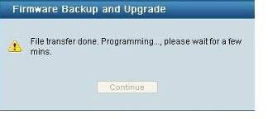

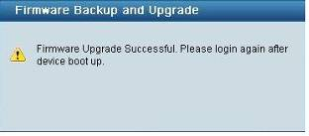

- Select TFTP to upgrade the firmware to or from a remote TFTP server.
- Enter the name of the firmware file located on the TFTP server
- Click Upgrade after selecting the firmware file you want to restore
- Click OK to continue with firmware upgrade

- Wait until the firmware upgrade ends and login again after device boots up.
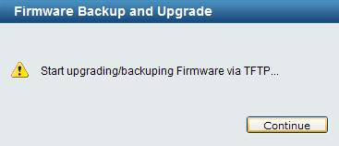

Upgrade using SmartConsole Utility
1. Connect a workstation installed with java SE runtime environment to any switch port of the device

2. Execute SmartConsole Utility
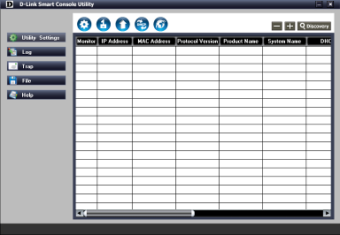

3. Click Discovery button to search target switch

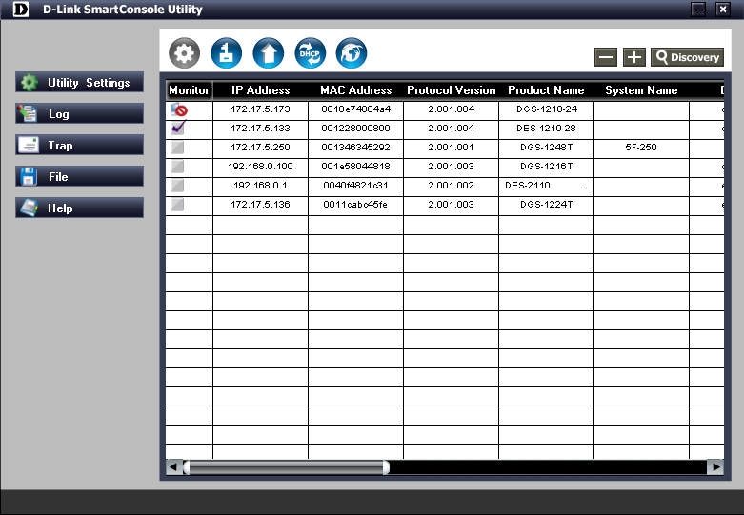

4. Single click the icon of Monitor column to choose the target switch

5. Click Firmware Upgrade button

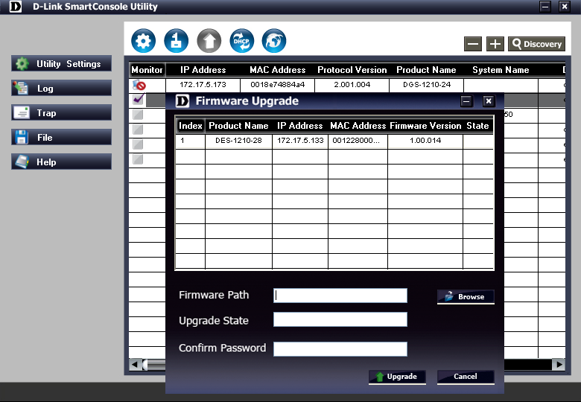

6. Click Browse button and select the firmware file (Model name_HW ver._FW ver. .hex) on your local hard drive.

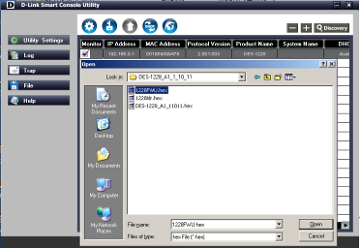

7. Enter password and click “Upgrade” button to start firmware upgrade. The default password is “admin”.

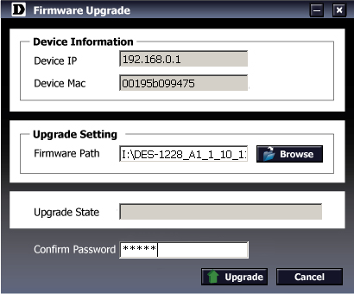

8. Once the message popped up, click “OK” button to complete the firmware upgrade

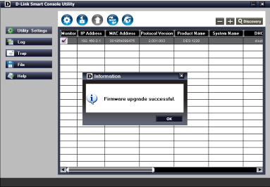

New Features:

Firmware Version | New Features
V1.00.018 | First Release

Changes of MIB & D-View Module:
The new features of MIB file are also included in the corresponding D-View module. Please download the D-View module from http://tsd.dlink.com.tw. For detailed changes of MIB content, please refer to the modification history in each MIB file.
Firmware Version | MIB File | New Features
V1.00.018 | DGS-1500-28P_A1_1_00_010.mib | First Release

Firmware Version | D-View Module File | New Features
V1.00.018 | DV_DGS-1500-28P_V1.0.0.7_FW_V1.00.018.exe | First Release

Changes of Command Line Interface:
The section below only shows command line changes that may bring backward compatibility issues with configuration settings for previous version of firmware.
Any new feature commands that do not have backward compatibility issues are not included in the below section.

Firmware Version | Changes
V1.00.018 | First Release

Problem Fixed:

Firmware Version | Problems Fixed
V1.00.018 | First Release

* D-Link tracking number is enclosed in ()

Known Issues:
Firmware Version | Issues | Workaround
V1.00.018 | - The settings as shown below cannot be chosen on Chrome and Safari Browser.  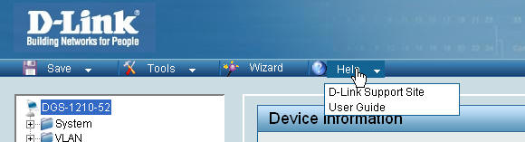  - DUT IP will be back to default IP address 10.90.90.90 under below conditions:  - All ports link status changed from link down to link up.  - After DHCP lease passed. | None

Related Documentation:
- DGS-1500-28P Series User Manual
- DGS-1500-28P Series Getting Started Guide

